Vernacular Names: Coconut Palm | Scientific Name: Cocos nucifera L.
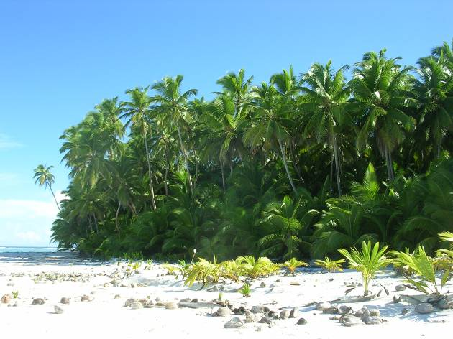 | 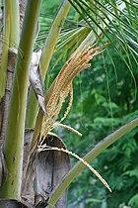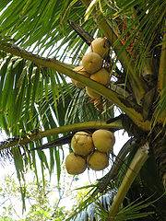
Full tree form | Details of leaf, flower & fruit
Native or Introduced: Native

Description: The coconut (Cocos nucifera) is the main member of the family Arecaceae or palm trees. It is a large palm, growing to 30 m tall, with pinnate leaves 4–6 m long, and pinnae 60–90 cm long; old leaves break away cleanly, leaving the trunk smooth. The term coconut refers to the seed of the coconut palm, which is not actually a nut. The tree is unmistakable.

Habitat: The coconut palm thrives on sandy soils and is highly tolerant of salinity. It prefers areas with abundant sunlight and regular rainfall (150 cm to 250 cm annually). Coconuts also need high humidity for optimum growth. In Chagos its success has been largely due to protection and propagation by man over the past two centuries.

Human uses: The coconut palm is grown throughout the tropics for its many culinary and non-culinary uses; virtually every part of the coconut palm can be utilized. Uses include oil from the nut for lighting, cooking, making bio-diesel, margarine; the white coconut flesh, is edible and used fresh or dried in cooking; coir - the fibre from the husk of the coconut - is used in ropes, mats, brushes, caulking boats and as stuffing; it is also used extensively in horticulture for making potting compost. The leaves provide materials for baskets, roofing thatch or reed mats. Burnt leaf ash provides a source of lime. The leaf midribs are used as poles and to make cooking skewers, kindling, arrows, and brushes. Coconuts are sundried for making copra - the dried meat of the coconut – from which coconut lighting oil is extracted, which was the origin for the alternative Chagos name – “the Oil Islands. The oil is used to make soap. Husk and shells can be used for fuel and charcoal. Superior activated carbon is manufactured from coconut shell, whose small macropore structure renders it more effective for the adsorption of gas/vapour, colour, oxidants, impurities and odour of compounds. Half coconut shells are used in the theatre, banged together to create the sound effect of a horse's hoofbeats, as the bodies of musical instruments, and to buff floors. Shirt buttons can be carved out of dried coconut shell. Coconut trunks are used for house construction. Palmwood is increasingly being used as an ecologically-sound substitute for endangered hardwoods, particularly in furniture and specialized construction. A dye is obtained from the roots, also a mouthwash, and a medicine for dysentery. A frayed-out piece of root can also be used as a toothbrush.

Significance: The species can be invasive, excluding other species through excluding sunlight.

Propagation: Grows very easily from the nut.

